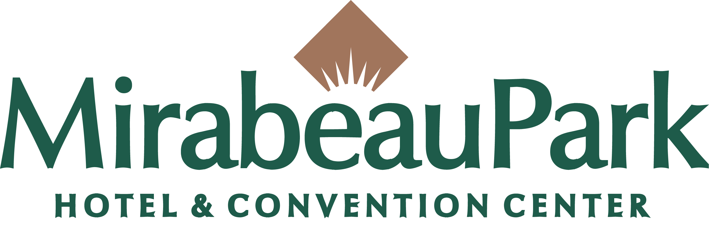

Convention Space and Sleeping Rooms Contract
Name:
Title:
Company Name: WSU
Address: PO Box 64XXXX

City, State, Zip: Pullman, WA 99164-XXXX

Phone: 509-335-XXXX
Fax: 509-335-XXXX
Email: XXXXXX@wsu.edu
Event Name: Washington State University Cooperative Pesticide Education

Hotel Name: Mirabeau Park Hotel & Convention Center
Sales Manager: Kay Riplinger

Phone: 509-924-9000
Fax: 509-922-6201

Name of Event: Washington State University Cooperative Pesticide Education

We are pleased to offer the following accommodations for your event:

SLEEPING ROOMS and RATES

Day | Date | Deluxe  $XX | $0.00 | $0.00 | $0.00 | $0.00 | Total Rooms
Monday
Tuesday
Wednesday
Thursday
Friday
Saturday
Sunday

TOTAL ROOM BLOCK RESERVED: XX

Room rates are quoted exclusive of taxes and fees, currently 10.6%. Quoted rate will be offered, based on availability, to your attendees 2 days before and 2 days after the above dates.

FUNCTION SPACE and FOOD AND BEVERAGE
SCHEDULE OF EVENTS

DAY | DATE | START | END | FUNCTION | ROOM | SETUP | ATTD | RENTAL
Tuesday | 1/15/2008 | 07:00 AM | 05:00 PM | Meeting | Spruce | Classroom | 100 | $0.00
Wednesday | 1/16/2008 | 07:00 AM | 05:00 PM | Meeting | Spruce | Classroom | 100 | $0.00
Wednesday | 1/16/2008 | 07:00 AM | 03:30 PM | Meeting | Juniper/Tamarack | Classroom | 250 | $500.00
Thursday | 1/17/2008 | 07:00 AM | 03:30 PM | Meeting | Juniper/Tamarack | Classroom | 250 | $500.00
Thursday | 1/17/2008 | 07:00 AM | 05:00 PM | Meeting | Spruce | Classroom | 100 | $0.00

TERMS AND CONDITIONS

RESERVATIONS: Reservations will be made by: Individual Call In no later than 12/15/2007.
After that date, you agree that we may offer unused rooms held in your block to other customers to reduce our losses and your obligations under the performance clause. Reservations requested by your attendees after this date will be accepted based upon availability.

COMPLIMENTARY ROOM POLICY: See Notes

SUMMARY OF SPECIAL CONSIDERATIONS: See agreement for meeting room rental. Should per diem rates change prior to the conference start the current per diem will be charged for guest rooms rates. One Comp room for instructor.

CANCELLATION AND PERFORMANCE: The rates offered by us are based in part upon the total gross revenue anticipated by us from your agreement to use and pay for the rooms and events listed. You agree and understand that in the event of a cancellation or lack of full performance by you, our actual damages would be difficult to determine. Therefore, you have agreed to pay reasonable liquidated damages to the Hotel for cancellation or lack of performance as described in this paragraph. Cancellation damages will be calculated as a percentage, based on the date of cancellation listed below, of total anticipated gross revenues from all contracted sleeping rooms, food and beverage and meeting room rental listed on the opposite side.

Date of Cancellation Percentage owed

Date of signing to 90 days in advance 10%

89 days to 60 days in advance 25%

59 to 30 days in advance 40%

29 days or less in advance of event 60%

If the event is held, but the Hotel does not realize the total revenue anticipated from your event, you agree to pay performance damages. The damages owed will be the amount necessary for the Hotel to receive no less than 80% of the total anticipated revenue from your event.

SERVICE CHARGE: 19% of all base prices (food, beverage, room rental, A/V, etc) plus applicable state or local tax will be added to your account as a service charge and distributed to servers, and where applicable, bussers and/or bartenders assigned to the Event. A portion of the service charge is not a gratuity and is the property of the hotel to cover discretionary costs of the Event.

PRICE INCREASES: There may be increases in prices due to unforeseen changes in market conditions at the time of your event. We will communicate these increases to you in advance. We will require written confirmation that you agree to pay these increased prices. Alternatively, we, at our option, may in such event make reasonable substitutions in menus and you agree to accept such substitutions.

SET UP CHARGES: Should extensive meeting room set-ups or elaborate staging be required, there will be a set-up charge to cover hotel costs and additional labor. If equipment is necessary that exceeds hotel’s inventory, then you agree to pay for the cost of renting this additional equipment. You agree to indemnify us for any damage caused to any hotel property as a result of drayage related to your event, whether caused by you, your agents, employees, contractors, or agents.

OUTSIDE FOOD AND BEVERAGE: Due to state law, you may not bring into the hotel alcoholic beverages. You must obtain prior approval before you bring any food or non-alcoholic beverages from outside sources. A Hold Harmless Agreement and Liability Insurance are required if food or beverage products not purchased and served by hotel staff are brought in for consumption by your guests. Service fees will apply to any outside food or beverage served in our function space regardless if hotel labor is required.

DISPLAYS AND DECORATIONS, YOUR PROPERTY: We are not responsible for any loss or damage to property belonging to you or your attendees and do not maintain insurance covering it. All displays and/or decorations will be subject to our prior written approval and we reserve the right to contract and charge for hotel staff to provide the labor for any installations or removals of such.

SECURITY: We have no insurance for and are not responsible for any loss or damage to your property. If required, in our sole judgment, in order to maintain adequate security measures in light of the size and/or nature of your function, you will provide, at your expense, security personnel supplied by a reputable licensed guard or security agency doing business in the city or county in which we are located, which agency will be subject to our prior approval. Such security personnel may not carry weapons. For the safety of persons and property, no fireworks or incendiary devices may be used indoors at the hotel. Group agrees to comply with all applicable federal, state and local laws including health and safety codes and federal anti-terrorism laws and regulations. Group agrees to cooperate with Hotel and any relevant governmental authority to ensure compliance with such laws.

FIRE SAFETY: All room sets must be in compliance with the local Fire Department regulations pertaining to occupancy load, mandatory aisles and ceiling clearance and fire exits. Any event, which has vehicle displays, fog machines, fueled cooking demonstrations; laser, exhibits (including tabletop) or extensive productions with staging and props must have a certified permit from the local Fire Marshall. All associated fees for permits, floor plan approval and stand-by fire watch are your responsibility and final approved copies must be received at least three days prior to the event.

Hold Harmless/Indemnification: Each party to this Agreement shall be responsible for its own acts and/or omissions and those of its officers, employees and agents in the performance of this Agreement. No party to this Agreement shall be responsible for the acts and omissions of those entities or individuals not a party to this Agreement.

WSU Insurance/Tort Claims: WSU and its officers, employees, and agents, while acting in good faith within the scope of their official WSU duties, are covered by the State of Washington Self-Insurance Program and the Tort Claims Act (RCW 4.92.060 et seq.), and successful claims against WSU and its employees, officers, and agents in the performance of their official WSU duties in good faith under this Agreement will be paid from the tort claims liability account as provided in RCW 4.92.130.

AUXILIARY AIDS: The Hotel represents and you acknowledge that the Hotel facilities being rented for you including guest rooms, common areas and transportation services will be in compliance with our public accommodation requirements under the Americans With Disabilities Act. You agree that one week in advance you will furnish to us a list of any auxiliary aids needed by your attendees in meeting or function space. You agree to pay all charges associated with the provision of such aids. When your attendees make room reservations, please ask them to notify us of their auxiliary aid needs so that we may notify you as to the names of businesses with which you may contract to obtain those aids.

DELIVERIES: Arrangements for delivery of packages should be made through the purchasing manager. Receiving, handling and shipping charges may apply. No COD packages will be accepted. The hotel policies on safe package handling are based upon advice from the United States Postal Service (USPS) and the Federal Centers for Disease Control and Prevention (CDC).

PROMOTIONAL CONSIDERATIONS: We have the right to review and approve any advertisements or promotional materials in connection with your function that specifically reference any name or logo of the Hotel.

Dispute Resolution: In the event that a dispute arises under this Agreement that the parties can’t resolve, they shall allow the dispute to be decided by a Dispute Panel in the following manner: each party to this Agreement shall appoint one member to the Dispute Panel, and the members so appointed shall jointly appoint an additional member to the Dispute Panel. The Dispute Panel shall review the facts, contract terms and applicable statutes and rules and make a determination of the dispute. The determination of the Dispute Panel shall be final and binding on the parties hereto. The parties shall equally share the costs, if any, for the services of the Dispute Panel.

FORCE MAJEURE: Neither party shall be responsible for failure to perform this contract if circumstances beyond their control, including, but not limited to; acts of God, shortage of commodities or supplies to be furnished by the Hotel, governmental authority, or war in the United States make it illegal or impossible for the hotel to hold the event.

AMENDMENTS/CHANGES: The parties agree that any amendments or changes to the arrangements described in this contract must be made in writing, signed by you and us, provided, however, that this contract includes all signed or unsigned banquet event orders (and the terms and conditions contained therein and attached thereto) issued by us for this and related events.

The terms of this agreement will be considered definite commitments upon signing of this agreement by both parties, and will be subject to all terms and conditions set forth on the following pages. You will be asked to sign Banquet Event Orders confirming the details of your events. Faxed signatures will be accepted. The persons signing below agree that they are authorized representatives of the above indicated group and Hotel who have authority to enter this contract. This agreement and the terms and conditions on the following pages may not be changed or amended unless done so in writing and signed by both parties.

By: By:
WSU, Danette Kriehn Director of Sales
Contracts Manager Mirabeau Park Hotel, Kay Riplinger

Date: Date: ____________________________________

DOS

